# High Level Architecture of ChatGPT created Threat Model

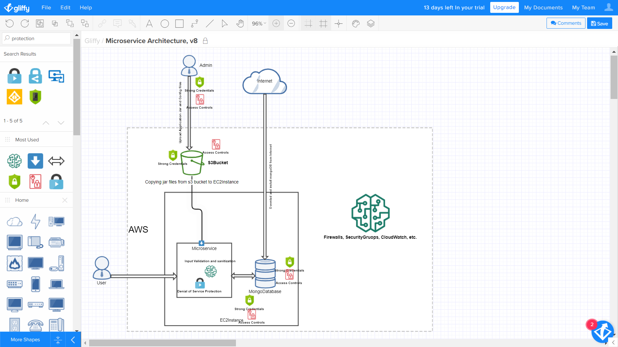

Figure : High Level Threat Model Diagram

## Asking ChatGPT to create a threat model for my microservice application

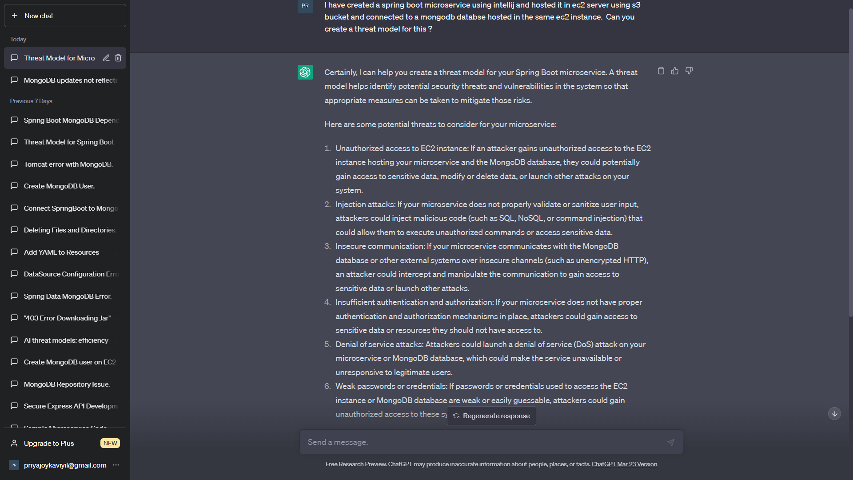

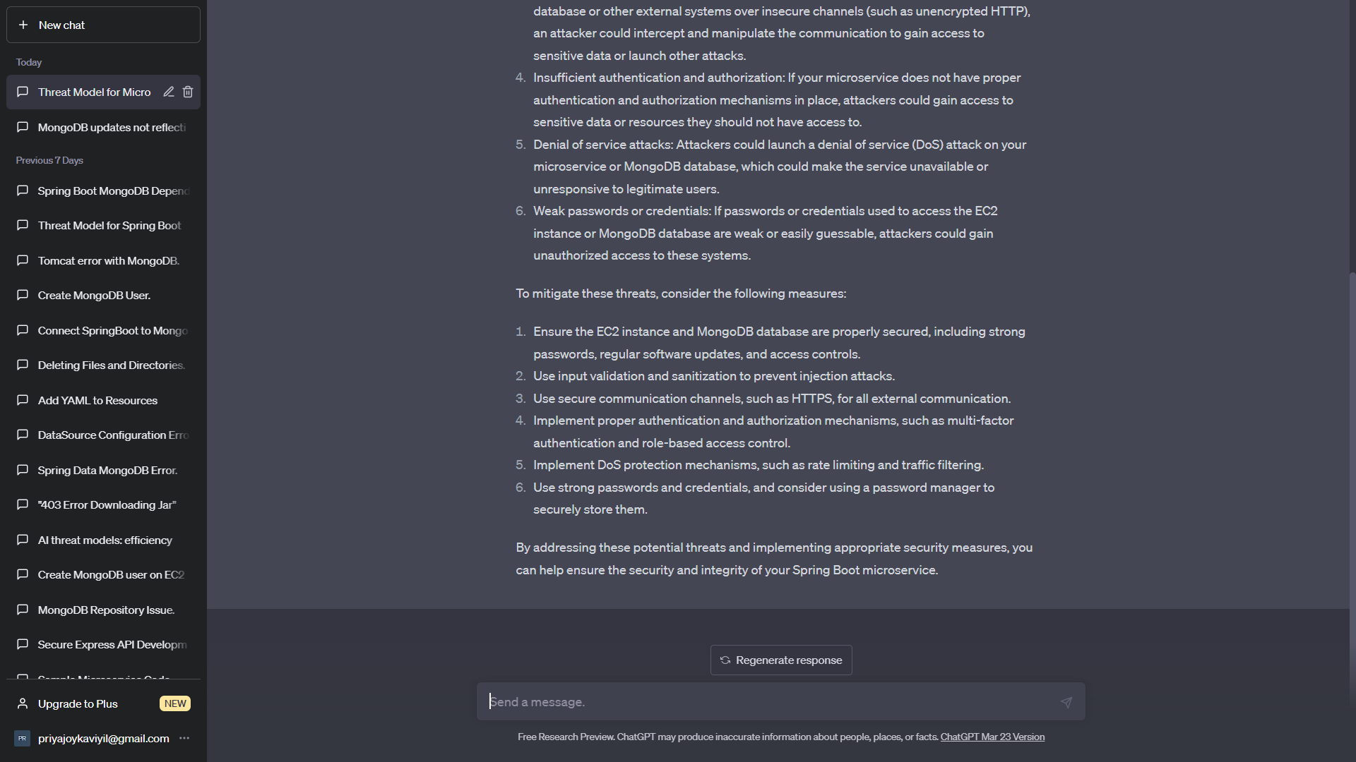

## Ensuring the security of EC2 instance and Mongo DB instance

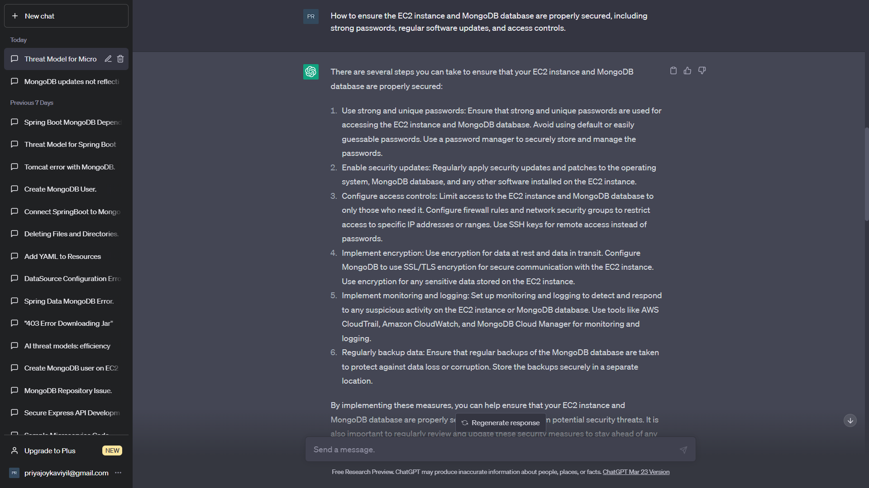

## Using input validation and sanitization to prevent injection attacks

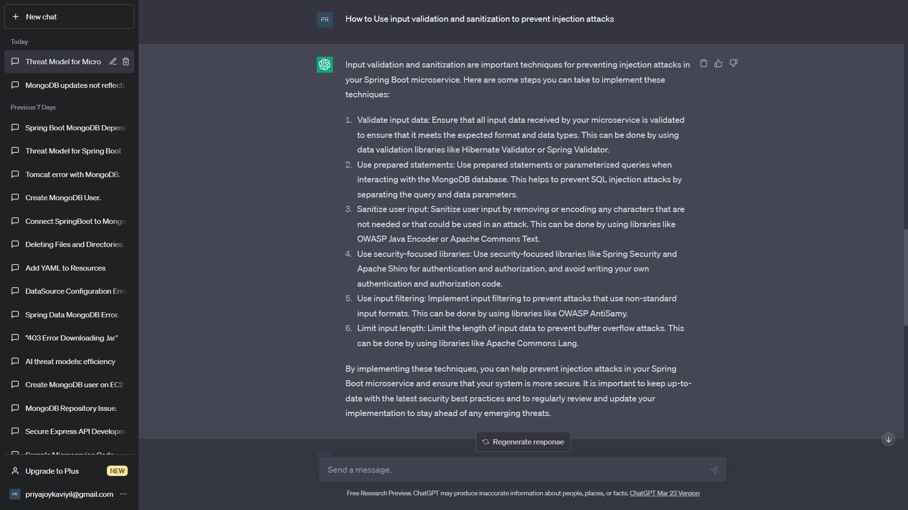

## Implementing multi-factor authentication and role-based access control

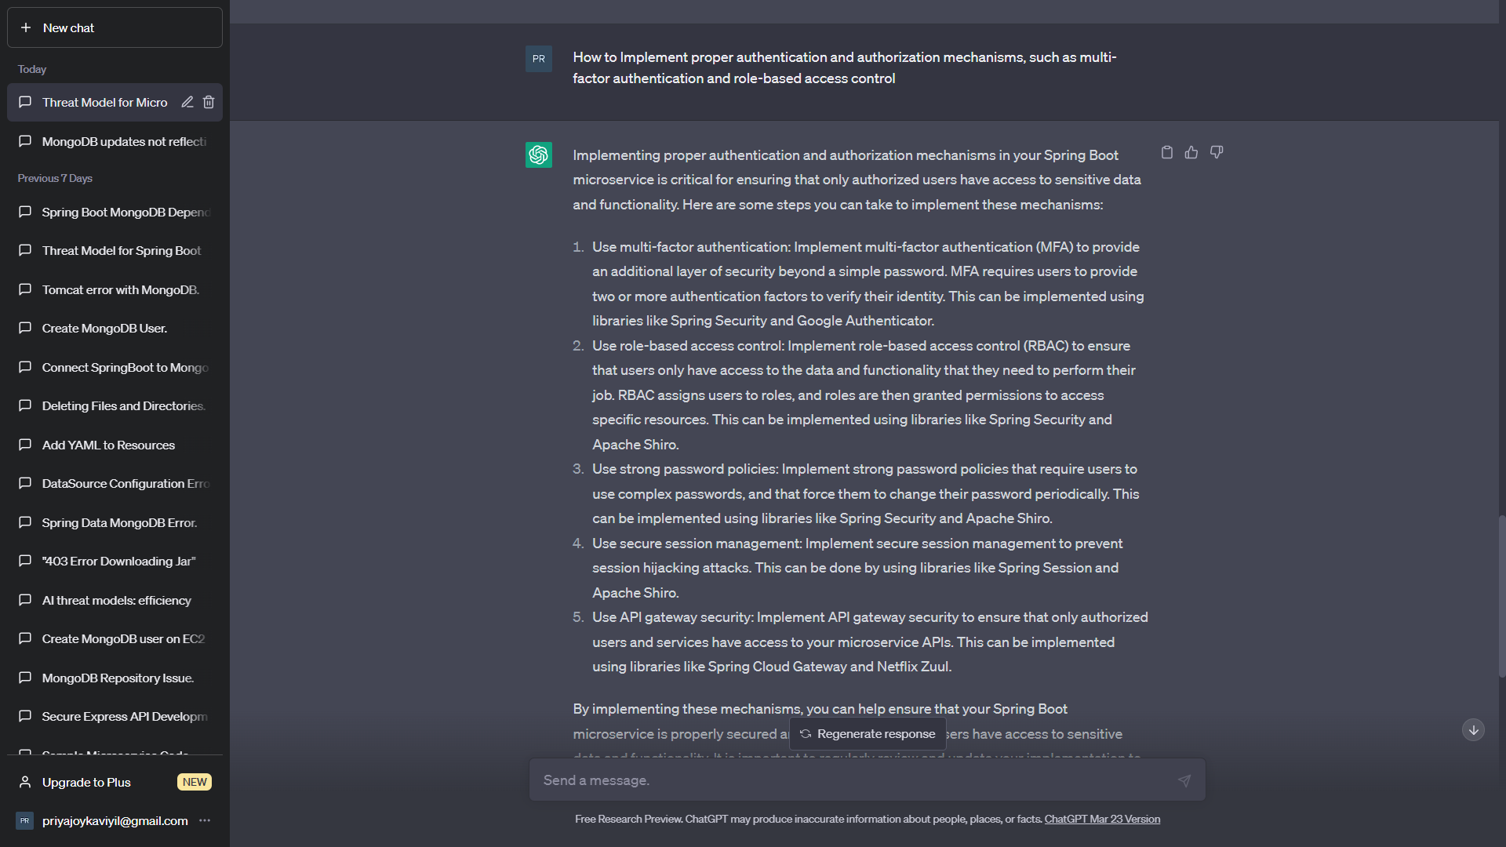

## Implementing DoS protection mechanisms, such as rate limiting and traffic filtering

